INSTALLING AND STARTING PHANTOMJS

This document guides:

* How to install PhantomJS in Window environment?
* How to start PhantomJS?

# Installing PhantomJS

At the current, I cannot access to <http://phantomjs.org/> so I don’t know how many ways to install PhantomJS. I only install it via nodejs and npm.

You need to install nodejs at <http://nodejs.org> into your local machine. Installing nodejs also installs npm at <https://www.npmjs.org/>.

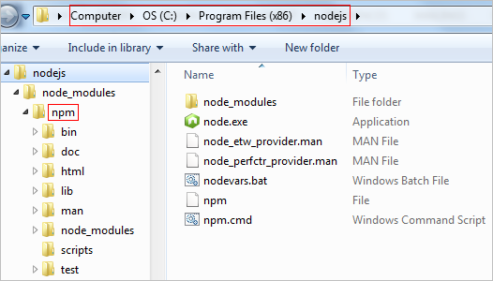

I assume that you have both nodejs and npm in your machine.

You can check nodejs version by command line:

*>node -v*

At the current, I use nodejs v0.10.29. You can check npm version by command line:

*>npm -v*

And I use npm version 1.4.14.

**Installing PhantomJS**

To use PhantomJS at every sources in your machine, you need to install PhantomJS with global mode. Using command line, you run:

*>npm install -g phantomjs*

This command installs PhantomJS at the directory for current user. You can check it at:

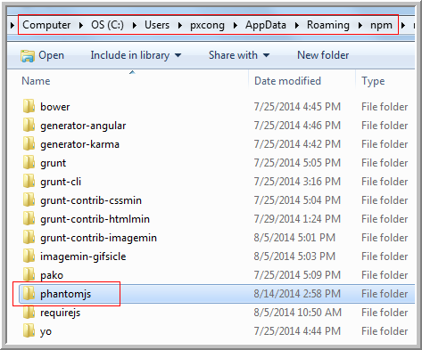

And you can check the version of PhantomJS by command line:

*>phantomjs -v*

Now, PhantomJS is ready to use. At the current, I use PhantomJS 1.9.7.

# Starting PhantomJS

You need to create new js file to configure PhantomJS to use one port and listen another port. Sample, I configure PhantomJS to use port 9090 to listen site <http://lawsonry.com:80>.

There are two ways to start PhantomJS:

* Run PhantomJS under npm. npm can be installed with nodejs and it is used to install PhantomJS but PhantomJS is not a library for nodejs. You can refer to <https://www.npmjs.org/package/phantomjs> for more details.
* Run PhantomJS standalone.

**Run PhantomJS under npm (nodejs)**

After installing PhantomJS with global mode and nodejs is existing in your machine then you can run PhantomJS via command line.

Sometimes, you need to install PhantomJS with private mode for each source. I will check it when you reach to this case.

**Run PhantomJS standalone**

You need the full source (include folder and file) of PhantomJS to run as:

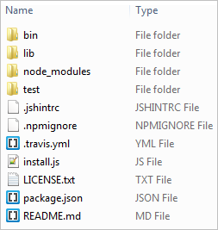

Expanding /lib/phantomjs folder then you can see phantomjs.exe. You need to configure the environment variables of Window to point to this folder.

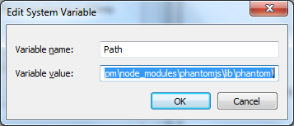

After that, you can use phantomjs at any folder. Sample, check the version of PhantomJS via command line:

*>phantomjs -v*

**Example: run PhantomJS**

In this example, I have angular-seo-server.js file to configure PhantomJS. It runs at port 9090 to listen site <http://lawsonry.com/>. I go to the directory that contains angular-seo-server.js file and the source code for my site. I start PhantomJS by command line:

*>phantomjs --disk-cache=no angular-seo-server.js 9090* [*http://lawsonry.com/*](http://lawsonry.com/)

And PhantomJS informs me that it listens at port 9090. Everything is ok.

Finish.